**Program 4: Write a JavaScript program to compare two strings using various methods.**

// js program to perform string comparison

//Using toUpperCase()

const string1 = 'JavaScript Program';

const string2 = 'JavaScript Program';

// compare both strings

const result = string1.toUpperCase() === string2.toUpperCase();

if(result) {

console.log('The strings are similar.');

} else {

console.log('The strings are not similar.');

}

**OUTPUT:**

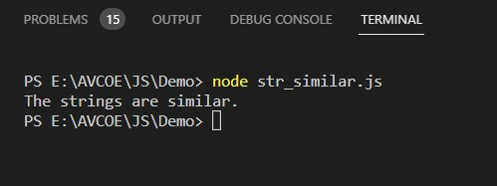

// program to perform string comparison

//JS String Comparison Using RegEx

const string1 = 'JavaScript Program';

const string2 = 'javascript1';

// create regex

const pattern = new RegExp(string1, "gi");

// compare the stings

const result = pattern.test(string2)

if(result) {

console.log('The strings are similar.');

} else {

console.log('The strings are not similar.');

}

**OUTPUT:**

